# CreateArt

Create a Web page (HTML5 + CSS3 + images) that looks and behaves like the screenshot below:

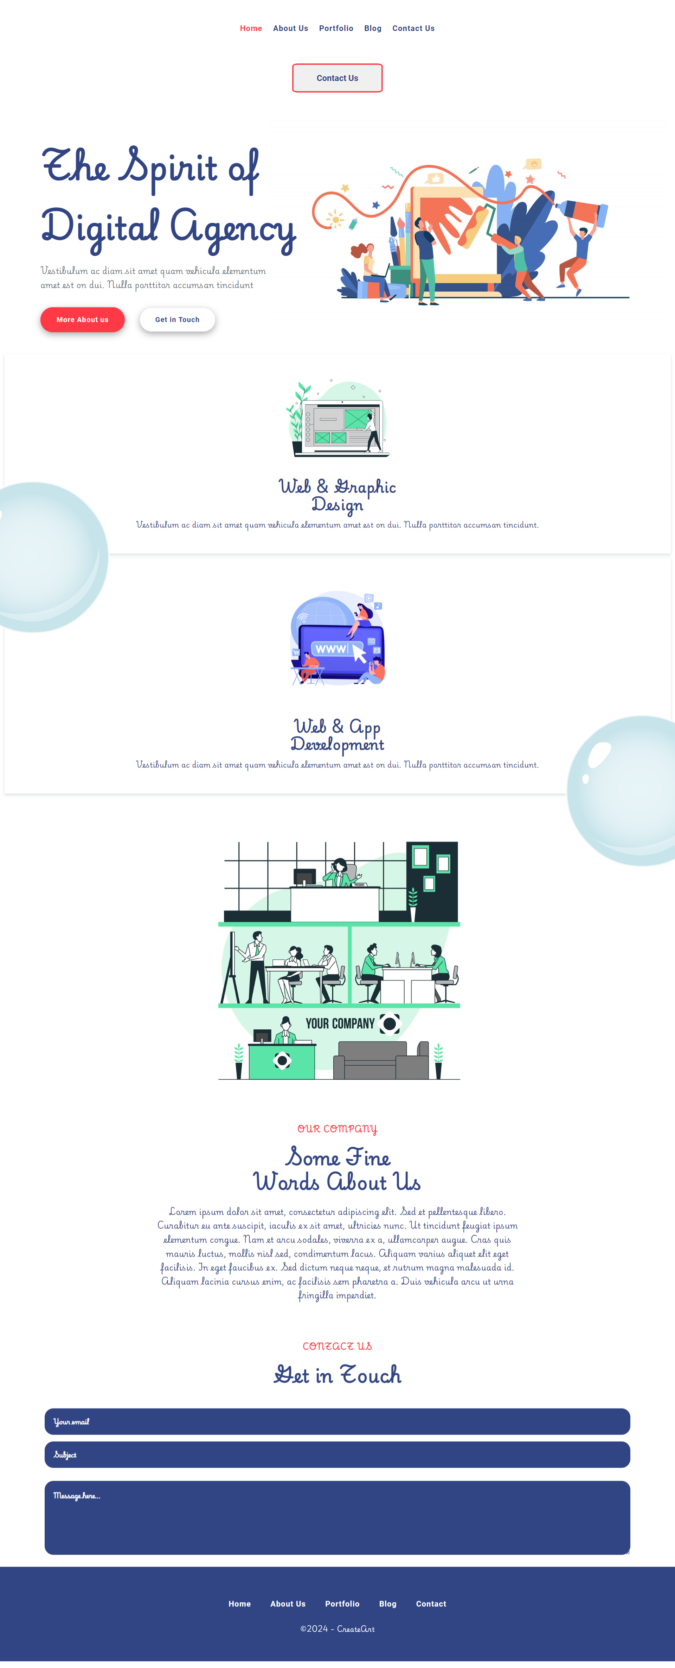

You are given the above screenshots + all required images.

## Output

The output should be valid **HTML5** + **CSS3** + **images** that implement the above web page.

## Constraints

* Use font 'Playwrite PE' for the text and font 'Roboto' for the buttons – (<https://fonts.googleapis.com/css2?family=Playwrite+PE:wght@100..400&display=swap>)  
  (<https://fonts.googleapis.com/css2?family=Roboto:ital,wght@0,100;0,300;0,400;0,500;0,700;0,900;1,100;1,300;1,400;1,500;1,700;1,900&display=swap>)
* The site should open correctly in the latest version of Chrome